## MongoDB Practice Assignment Aarthi. P

test> db.createCollection("col1")

Screenshot 2025-07-24 at 10.43.36 AM

test> db.col1.insertMany([

|   { name: "Aarthi", age: 21, course: "Data Science", city: "Chennai" },

|   { name: "Ravi", age: 25, course: "Web Development", city: "Bangalore" },

|   { name: "Sneha", age: 19, course: "AI & ML", city: "Hyderabad" },

|   { name: "Rahul", age: 22, course: "Cyber Security", city: "Mumbai" },

|   { name: "Priya", age: 24, course: "Data Science", city: "Delhi" }

| ])

test> db.col1.find()

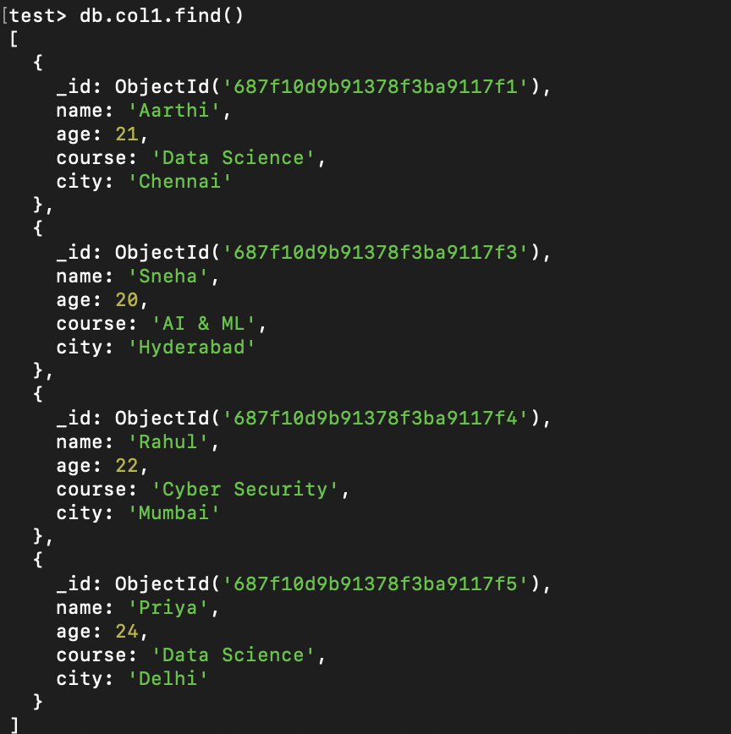

test> db.col1.countDocuments()

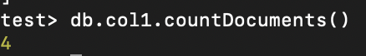

test> db.col1.find({ age: { $gt: 22 } })

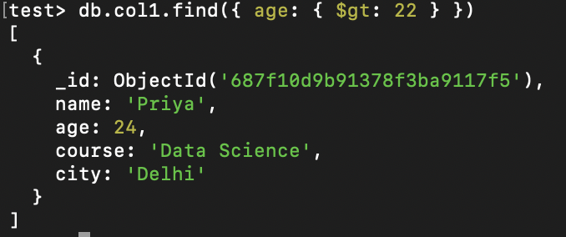

test> db.col1.find({ course: { $regex: /Data/i } });

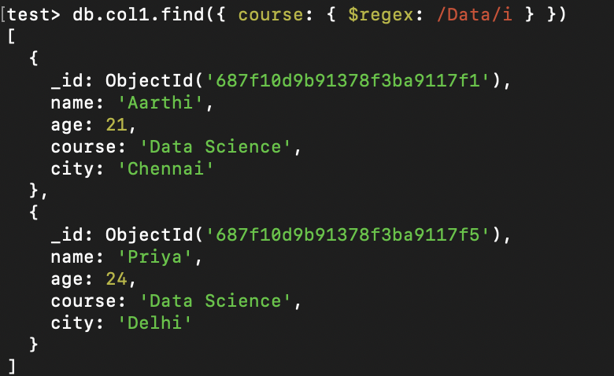

test> db.col1.find({ course: { $regex: /Data/ } })

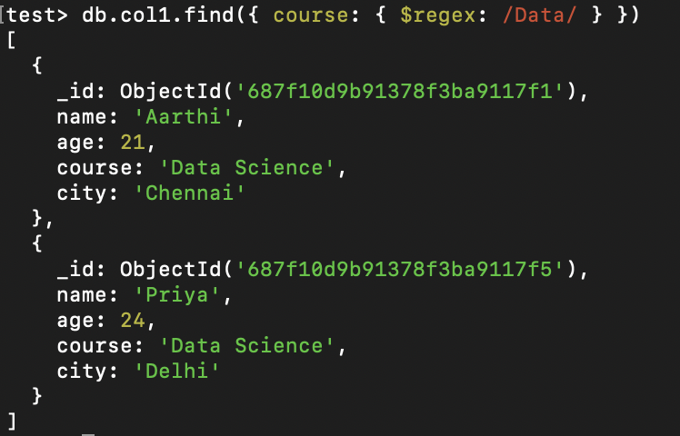

test> db.col1.findOne( {course : "Data Science"})

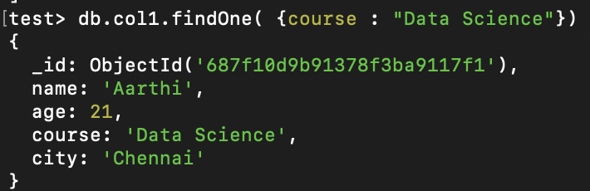

test> db.col1.updateOne( {age: 19},{$set: {age: 20}})

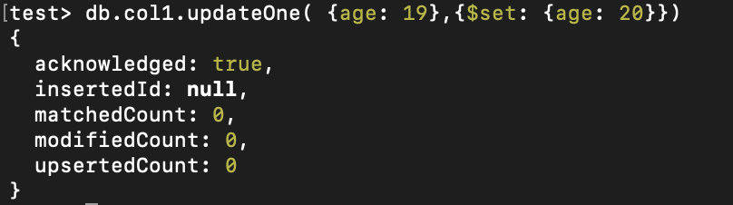

test> db.col1.findOne( {course : "AI & ML"})

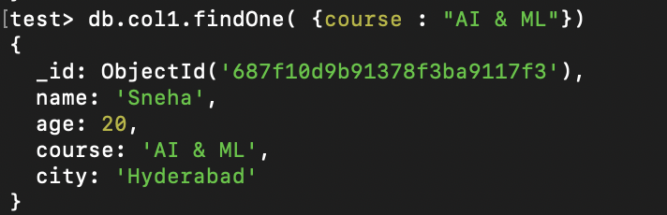

test> db.col1.deleteOne( {course: 'Web Development'})

Screenshot 2025-07-24 at 10.41.06 AM

